Phoenix

Overview

Phoenix is a PACS accessory – a software application that converts secondary captured non-DICOM images into DICOM images and transfers converted images to a DICOM server. It also has the functionality to associate the scanned images or reports with the patient study data.

Functions

* It helps capture images from any Non-DICOM modality and convert it to DICOM format
* Phoenix converts JPEG , BMP, AVI to DICOM
* Converts scanned documents and digitized film to DICOM
* Integrates with any PACS



Features :

* Query Patient information from any DICOM modality or DICOM server or DICOM Workstation or Modality worklist server.
* Search parameters include patient ID, Name Sex, Study Date, Accession Number and Modality
* Capture Images/ Cine loops from Non DICOM modality
* Import images – jpeg, bmp, AVI and DICOM images
* 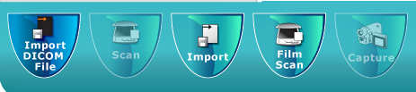
* Scan reports and documents
* Import images from digital camera
* Import digitized film from Film Digitizer (VIDAR)
* DICOM conversion – Convert captured images & documents into DICOM 3.0 format and send to DICOM server
* DICOM DIR – Store images locally or write DICOM Dir
* Review and select – Review images before DICOM-izing them.
* Burn CD/DVD with embedded DICOM viewer
* 